**CSA1519- CLOUD COMPUTING FOR BIG DATA ANALYTICS**

**LAB EXPERIMENTS**

**NAME : P SUDHARSHAN REDDY REG.NO: 192372204**

**EXP NO 10. Create a Cloning of a VM and Test it by loading the Previous Version/Cloned VM using virtual box.**

**AIM:**

To create a clone of a virtual machine in VirtualBox and test it by loading the cloned VM.

**PROCEDURE:**

STEP 1: Open Oracle VirtualBox and select the virtual machine you want to clone.

STEP 2: Go to Machine → Clone.

STEP 3: Enter a name for the cloned VM.

STEP 4: Choose the type of clone:

• Full Clone, Linked Clone

STEP 5: Click Clone → Wait for the process to complete.

STEP 6: Start the cloned VM → Verify that it works independently and has the same state as the original VM at the time of cloning.

DESIGN:

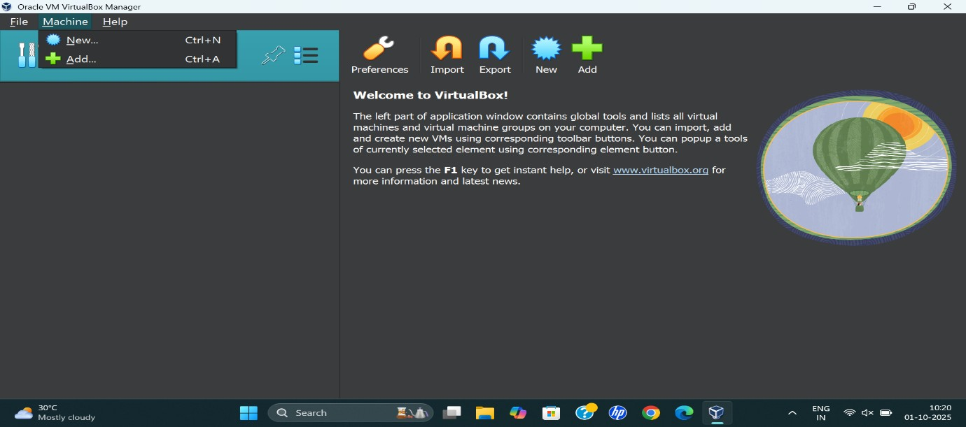

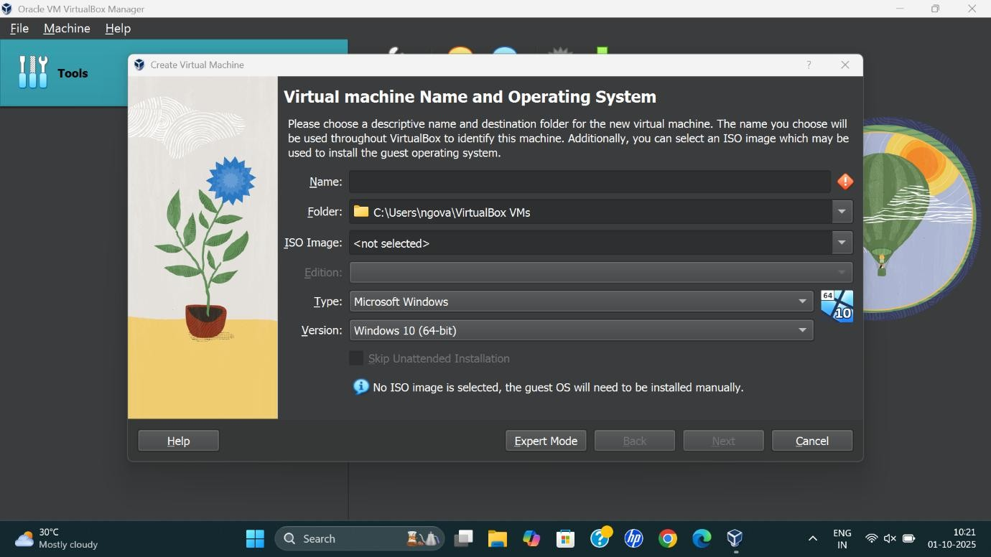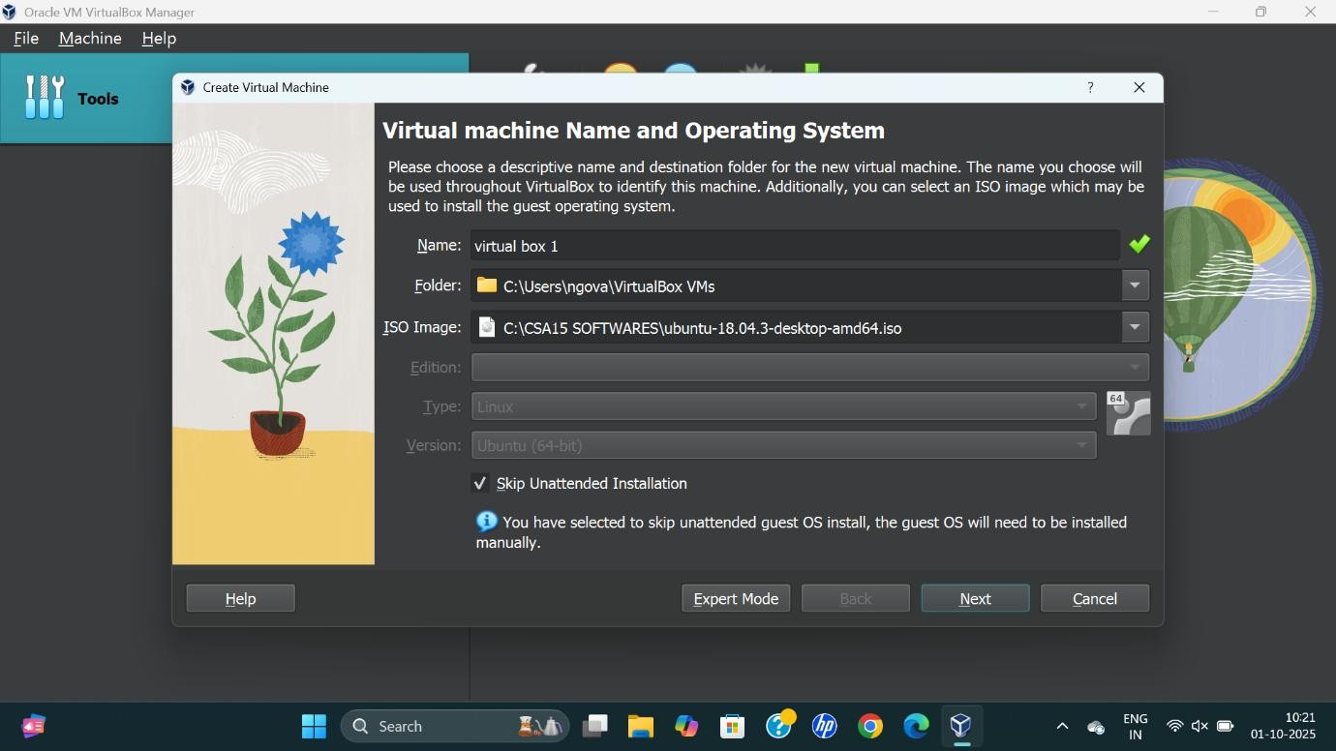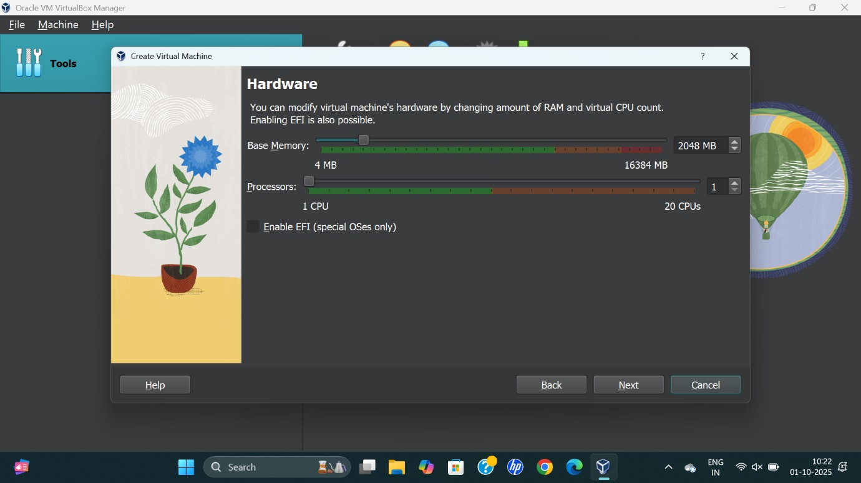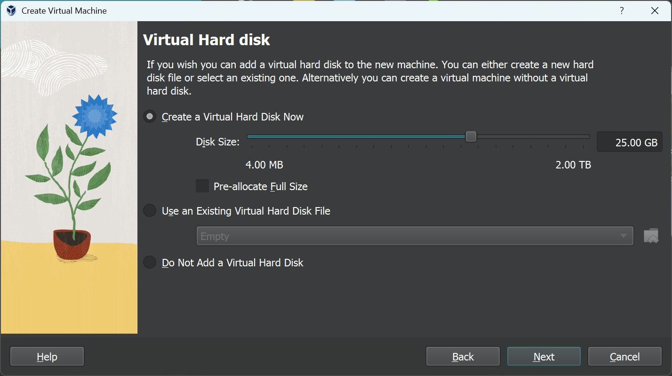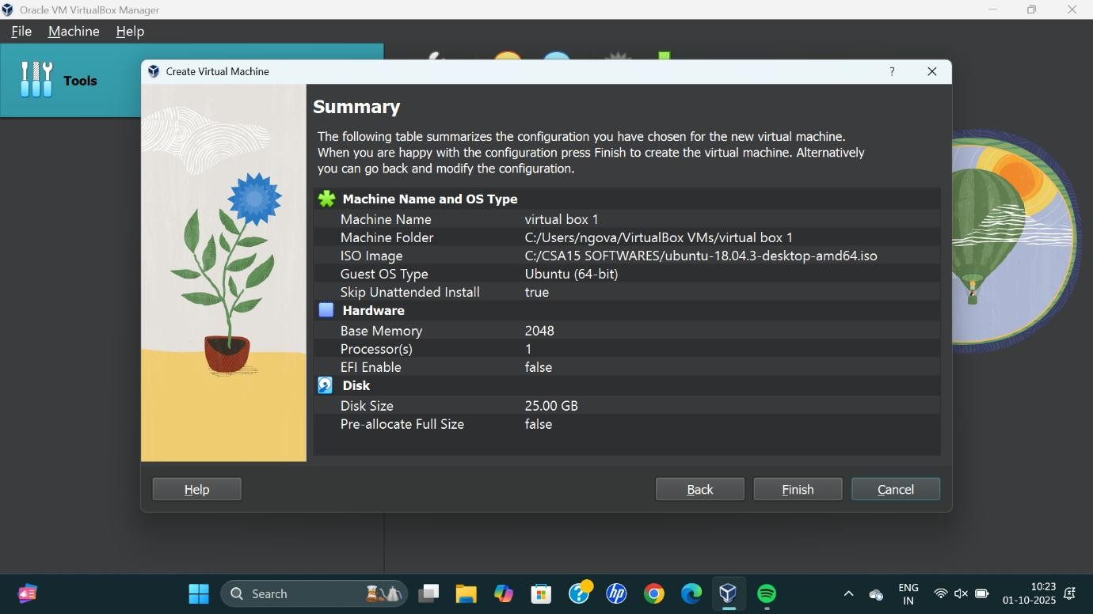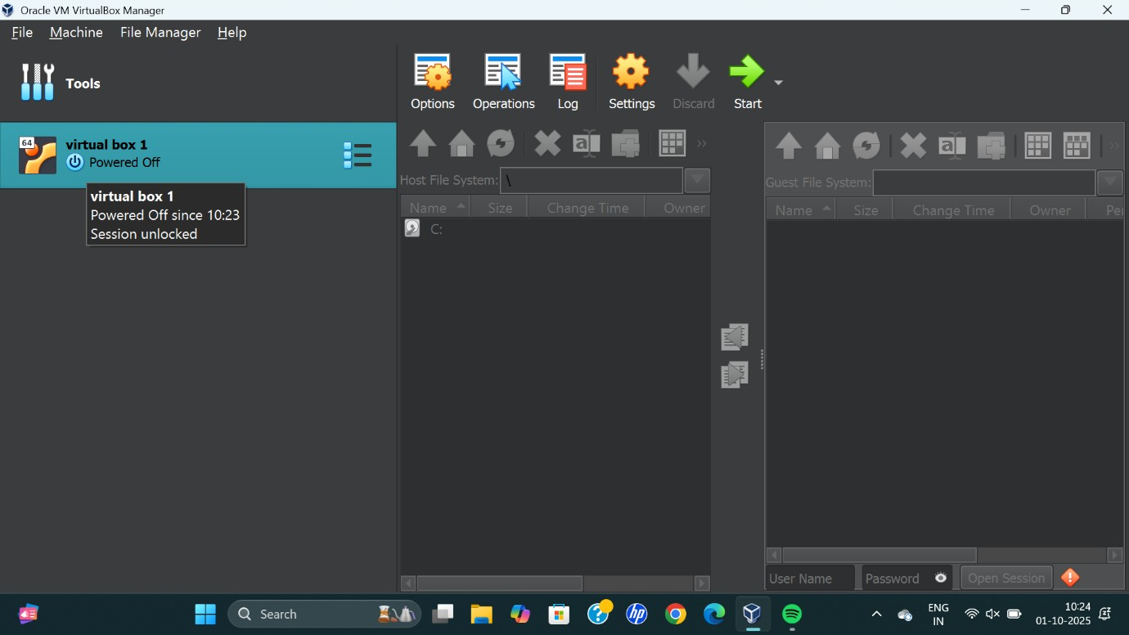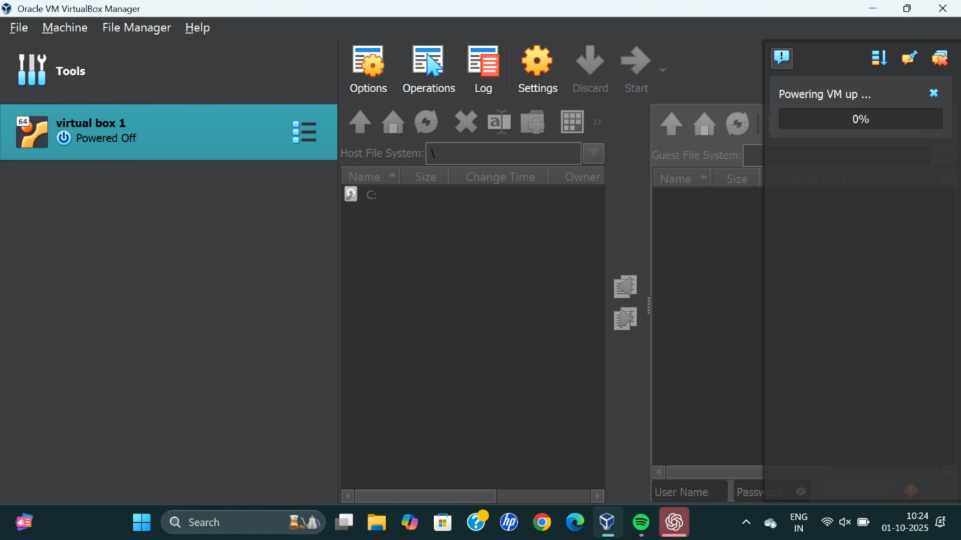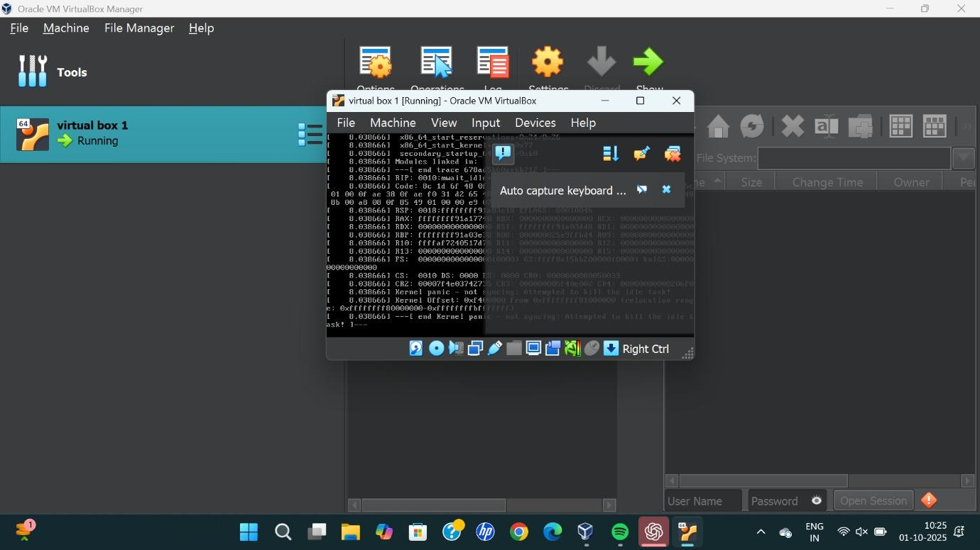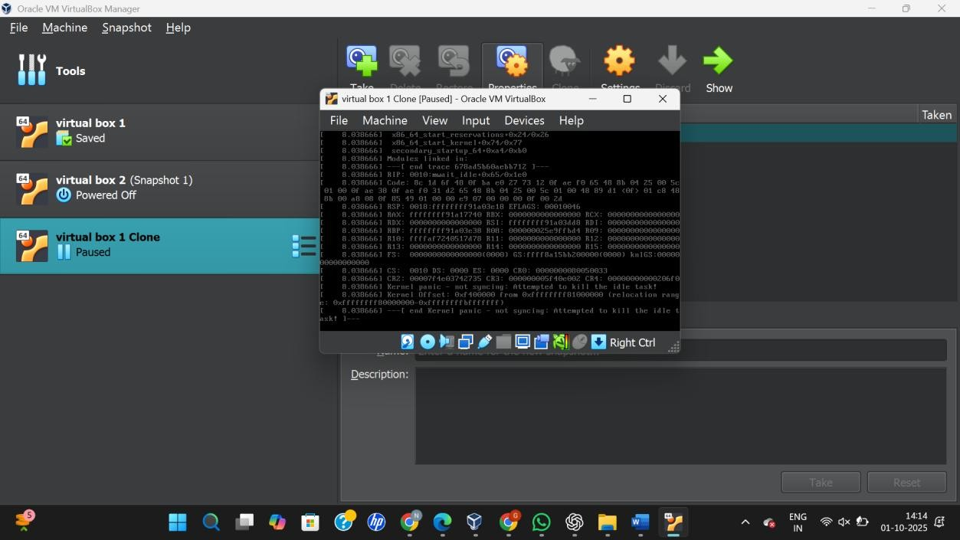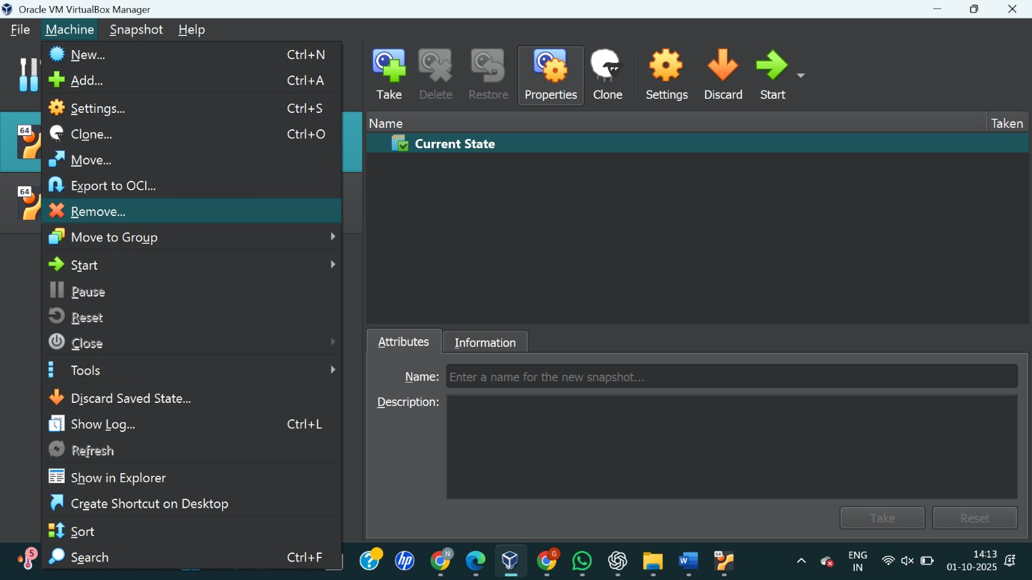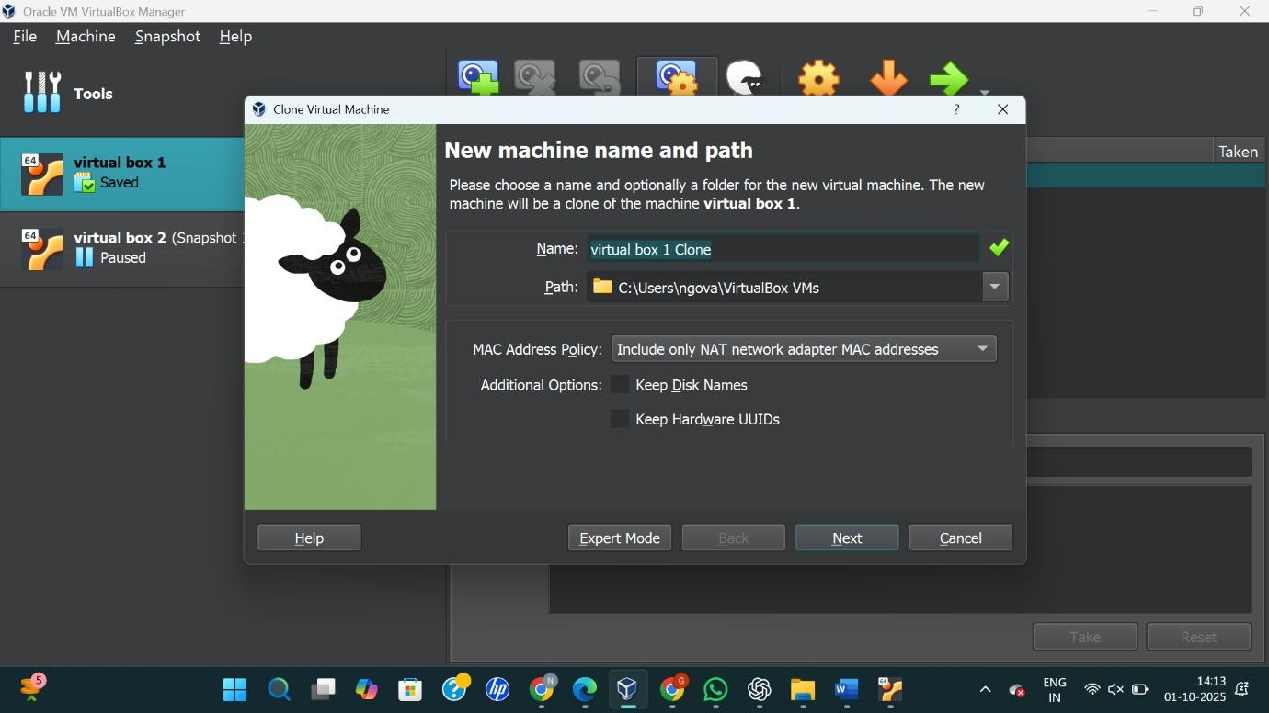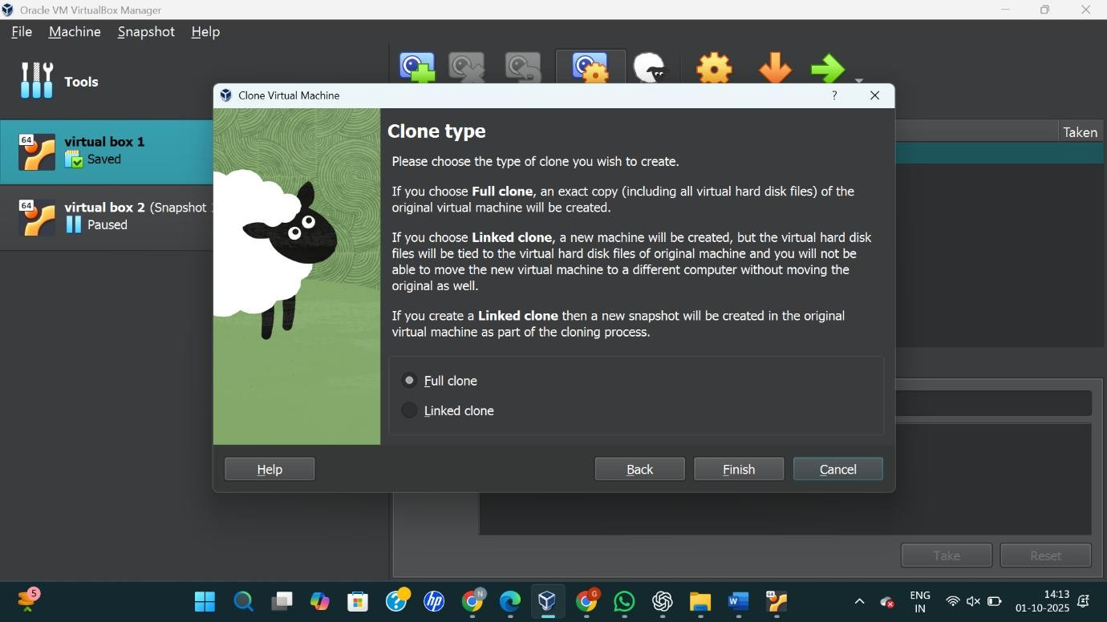



**RESULT:**

A virtual machine was successfully cloned in VirtualBox and tested by starting the cloned VM, confirming it loads correctly with the previous state.